- Chola King
Early Medival

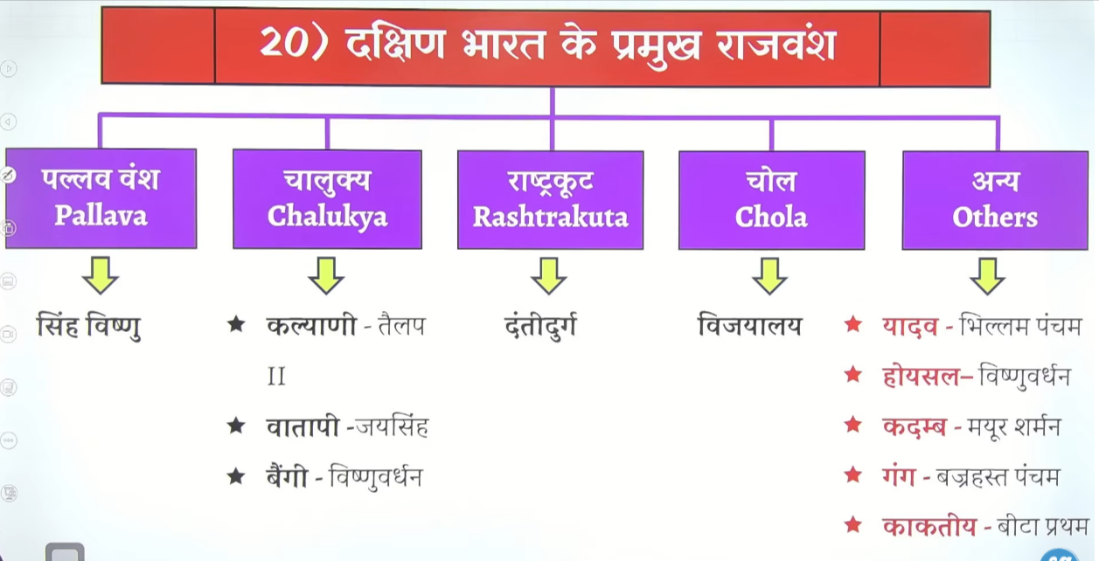

Inhone south east ke bahut sare island per adhikar kyia tha
Like sumatara, Thailand combodia, malesyai in chetroa me shree vijay naam ka empire tha unko harya tha chola ne aur itne bade Chetra per adhikar kyia
Shirland and maldeev per bhe adhikar kyia tha

Ancient choal and medival chola dono ke beech me bahut bada antar dekhaee deta hai dono ke beech me ek bahut bada duration gap hai
Medival time per hume chola and padnya ko he padna hai chera ko nahi padna hai and pandy ka bhe utna ullekha nahi main chola hai
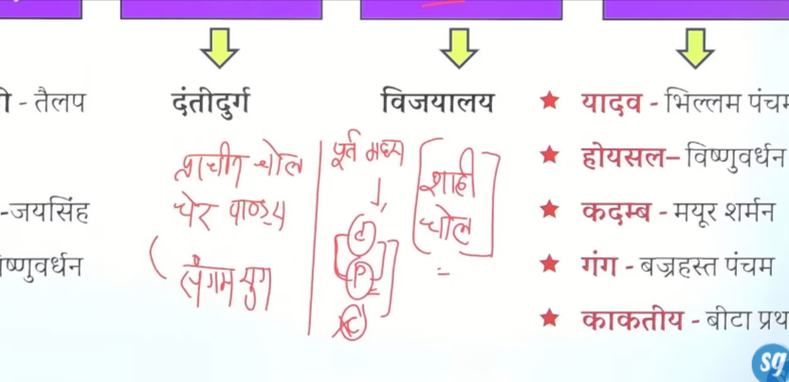

Pandya utne bade shakti ke ruoop me nahi aye the kaktyai bahut bade Chetra per shahn kar rahe the
Rudramdevi jinka ullekha marcopolo ne bhe apne yatroan me kyia hai

Chola ka prashaan jana jata tha local adminstartion ke lyie isthanyea prashahan k lyie
Bharat ka vahah kaun sa rajvanssh hai jo isthanyia prashaan k lyie praseedh hai
To answer is chola

Ek bahtu he Jayada systematic local governemtn ka structure inhone banya tha gramsabha ke paas bahut sare shaktyia hote the bahut sare samiteya hote the jo ek saal ke lyie chune jate the

Kaala ka bhe bahtu vikas hua ek to hume yaha Natraj murtyia dekhne ko milte hai chola ke shashan kaal me bronze ke kansya ke Natraj murtyia bahut he Jayda famous hue hai
Bhagawan sssshiva ko nrtya mudra ardhnareshwar mudra me dekhate hue Natraj murte bane gaye aurbhagwan shivva ke dakshineswar mudraye bhe bane gae hai jaha bhagwaan shivva vaat vraksh ke neeche biahte hue hai unhe ek teacher ke roop me dekhaya gayay hai
Ye wo samay tha jb Dravid kaala apne charma par pauch gae hume brahdeswar jaise mahan mandir deekahe denge tanjaur ya tanjavr me brahdeswar ya raj rajesware ka mandir banya gaya jiska 80 90 tonn ka jo kalash hai wo bahut bade ramp ke dwara hatyion ke help se uppar tk le jaya gaya tha wo bhe hume dekhne ko milta hai to uske saht bhaut sare mandir bhe dekhne ko milenge

Inka sahsan kaal praseedh hai navy ke lyei nausena k lyie bahut bade paimane per jo nausena ka vistar kyia hai wo cholo ne kyia nausena ke sahayata se inhone maaldeev , srilanka, indonesaia Thailand etc ke kuch parts per bhe kabja kyia tha
Evne wo Bengal ke paaal shashako ko bhe harakar aye the to itne Pradhan nausena rahe hai inke
To ye jane jate hai nausena ke lyie
Local admistration k lyie isthanyea prashan k lyei
Dravin madniro k lyie
Natraj ke murtiyon k lyie
Dakshineshwar ke shivva murti k lyie
In saab k lyie chola bahut he Jayda praseedh hai

Ur – gram sabha ke lyie use hone walal word hai

Capital is tanjaur tanjaur inka pramukh kendra rahega

Gangadekonda cholr puram jisko paal rajayon ke wara jeetne per banya gaya tha

Nagpattnam inka famous prot tha aur kaveripattnam bhe

Anuradhapuram srilanka ke purane Rajdhani the fir yaha polanaur name se new rajdahne bane the
Shree vijay ka pura empire bhe inhone jeeta tha
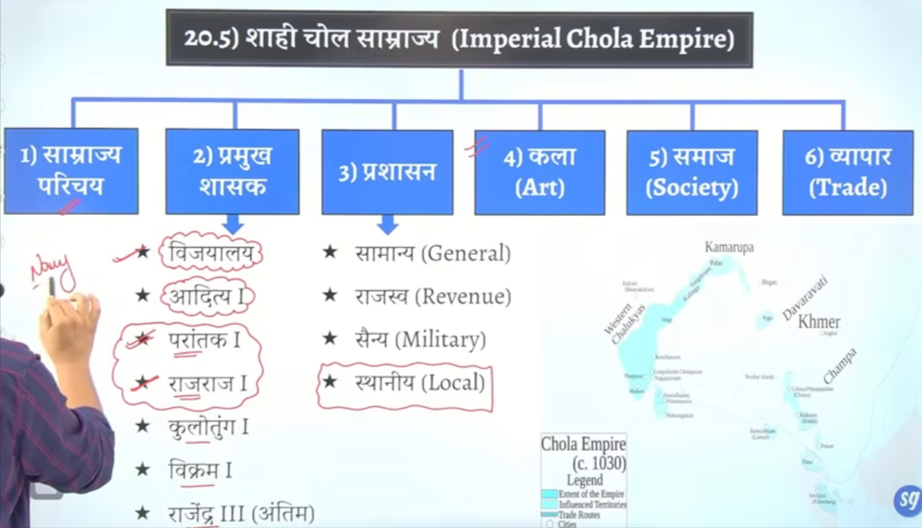

Chola ke founder vijayalay hai jinhone narkesare ke upadhe dharan ke the

Ye pahle pallavo ke antargat samant ka karya karte the
Fir vijaylaya ne swatantr rajya ke isthpana ke the
Inhone apne Rajdhani tanjaur ko banay tha joki tamilnaidu me hai
Jiske vastukaar rajraj peruthacchan the fir yaha per vijayalay ke dwara neeshubhsudani mandir banya gaya tha
Adhikansh chola rajaj bhagwaan shaaav ke upasak the
To cholo ke antargat shaiv sampradya ka bahut he adhik vikas hoga adhekansh mandir jo dekhoge wo Bhagwan shaivv ke he dekahe denge

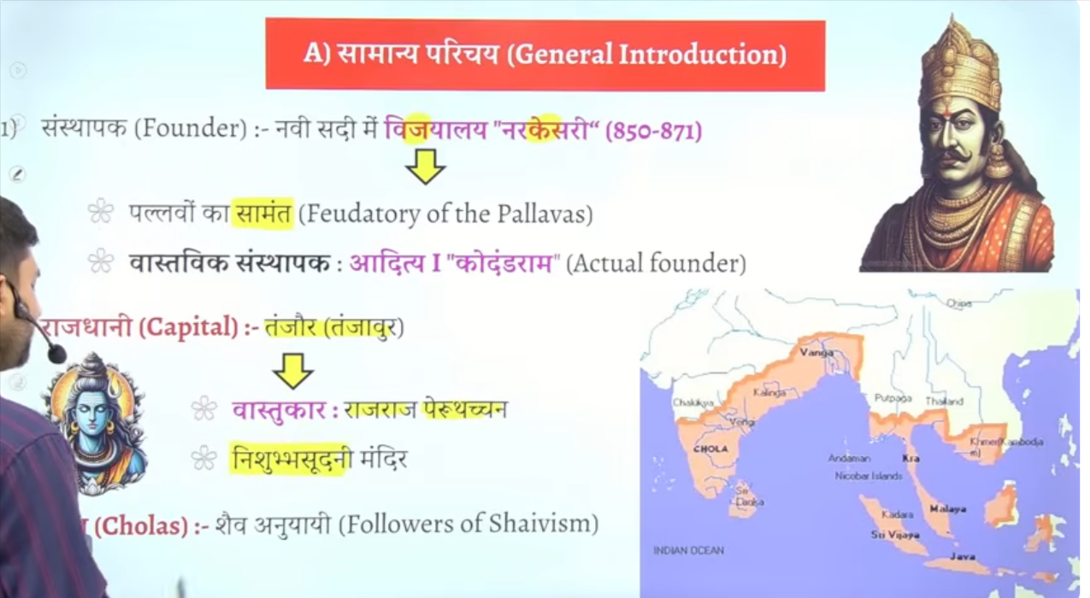

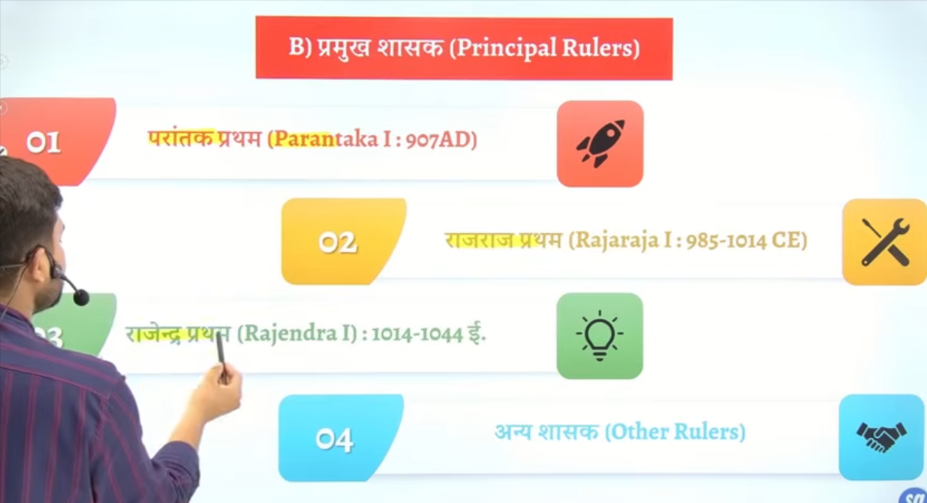

Uttrameru inscritpon tamilnadiu ke Kanchipuram me ke mandir hai us mandir ke deewaro per lekh ko likha gya ye uttrameru inscirpton jo ke Kanchipuram se mila hai wo parantak Pratham se juda hai isme hume isthaneya prashasn local administration ke bahut detail information milte hai

Yahe se hume ye chez dekhaee de ke south me madndiro per lekh nahi lekeh jate the north me likhe jate the
Wastav me wo chol raja he the jinhone mandiron ke dewaron per lekh likhwana start kyia tha
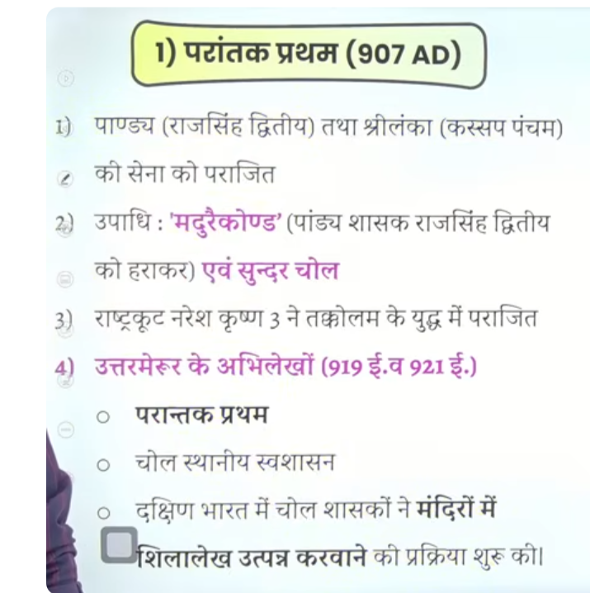

Inke paas do title the dek tha sundar chola and dusra tha maduraee Konda
Jb chola shasn kar rahe the to madurae wale ilake me pandya rajao ka shashan tha inhone padnya rajaon ko harakarke maduraee Konda ke upade dharan ke the
Inhone srilanka per bhe akraman kyia tha aur srilanka ke rajaj ne bhe inke samen atmsamparpan kyia tha tb srilanka ke Rajdhani anuradhapuram the
Srilanka ko celon bhe kaha gya hai aur pruva ka mote bhe kaha gayay hai

Parantak pram ne Kanchipuram tamilanadiu me ke ganon hai jiska naam hai uttrameru yaha per shri Venkatesh mandir hai is madnir ke dewaro per haum inscritoion dekhne ko milte hai is abhelekh me gramin swashasan ke sabse pahle charch keg ae hai isme rural administration ke baat keg ae hai ye mandir Bhagwan Vishnu se juda hua hai
Kuki ye mandir uttrameru gaon me hia isley isse uttrameru abhilekh kaha jata hai
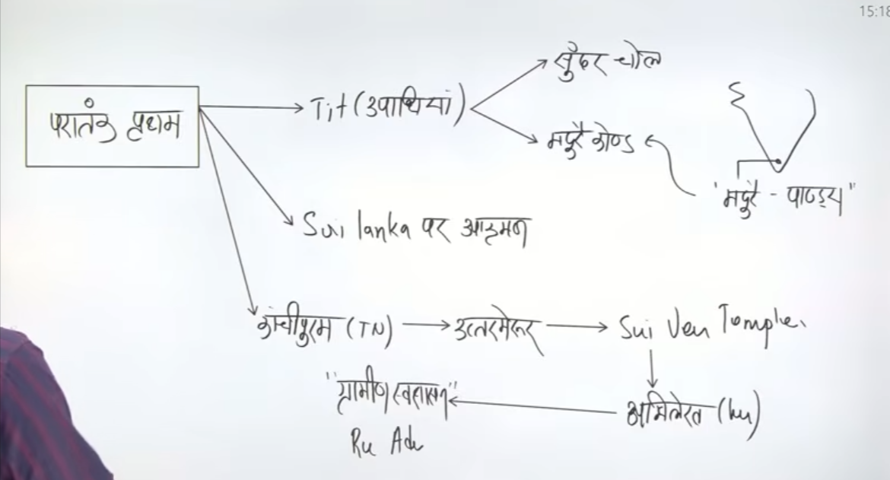

Rajraj first

Inhone isthaee jaal sena ka gathan kyia tha navy pahle bhe the to vastvek nausena bane ka sherya rjarja Pratham ko he jata hai inhone bhaut he powerful navy ko established kyia tha
Srilanka per sirf akaman kyia tha parantak Pratham ne inhone north srilanka ke bahut bade hisse per adhikar kar lyia tha
A south east me jo indoneswia Sumatra, java yaha 12 rajon ka shashan tha wahah er bhe inhone attack kyia tha
Indonesia wale state ko shreevijay kahah jata hai whaha ke rajaj Shailendra ne animate mange the hume nagpattnam me ke buddha vihar bana leene do kuki waha buddhism promote ho chuka tha whaha buddhism fail chuka tha

Srilanka ko jeetenke baad inhone jaygonda ke upade bhe dahrn ke the
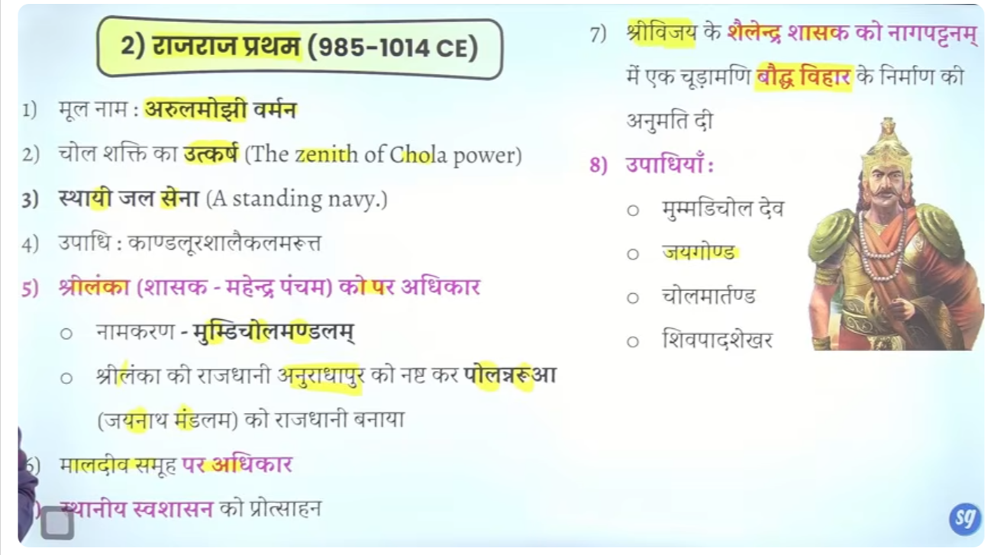

Iss time per north me mahmud gajanvi ke akraman ke Shurat ho chuke hai
Inhone sirf north sirlikan ko jeeta tha
Inhe ke tiem per vastvek roop se navy ko established kyia gyaa tha
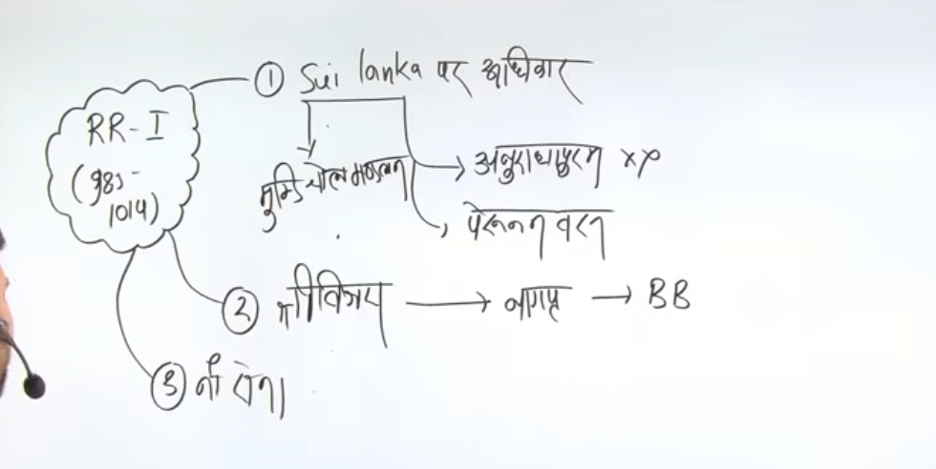

Inhone isthanye swasahn self governance ko badwa dyia tha

Rajendra Pratham

Ye bahut he bamahn rjaja hua inhone srilank ke jo hisse ko inke pita ne chod dyia tha inhone us per bhe adhikar kar lyie tha to inhone upura srilank vijit kyai tha
Aur sourth east ke jobe rajya the srivijya wagarh inhone un per bhe adhikar kar lyia tha
Inhone
Vinsent aurther smith ne inhie south ka nepolian bhe kha tha

Bengal ke paal rajaj ko harane ke baad title liya gangayakondacholpuram and aur trichinpilli ke paas gangaekondacholpuram naam ka new shara basya tha
Inhone land revenue system ko bhe dthek kyia tha refom kyiatha bhu rajsav me
Aur bhumi ke map ke dwara bhu rajasav ko taya kyia tha
Bhumi mapan ke lyie nae ekae shru ke the malegaae kool
Alag alag shashko ne land ke measurmenet k lyie alag alag unit shur ke the

Bengal ke khade ko inhone kaha tha ke ye cholo ke jheel hai it is lake of cholas
Bay of Bengal ko lake of cholas boal tha ku kahah tha kuki shree vijya ke 12 island per inhone adhikar kar lyia tha
Aur karna ye tha ke yaaha per china ke vaypare hote the jo bhartyia vyapareyon ko pareshan karte the kae baar inhone shree vijay ke rajao se kahah ye samasya aa rhea hai aur jab ye baat unhone nahi mane the apne traders ke paobmel ko resolve karne k lyie inhone south ease asia ke 12 isaland per adhikar kar lyia tha ]\]\

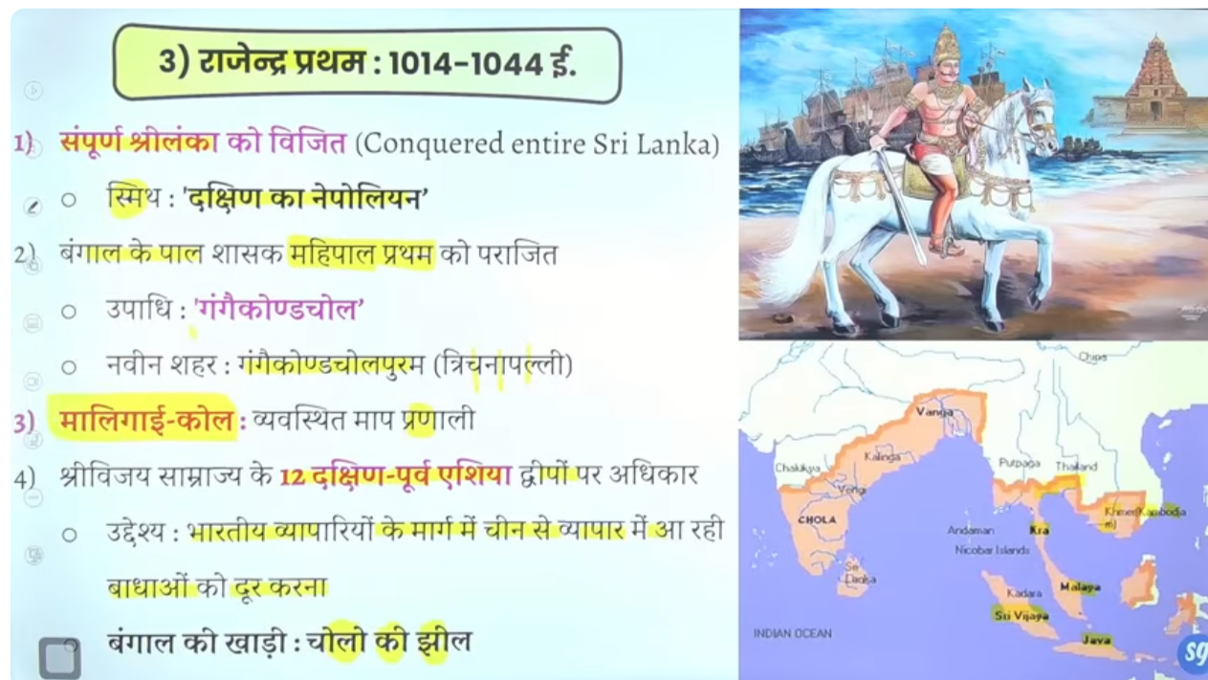

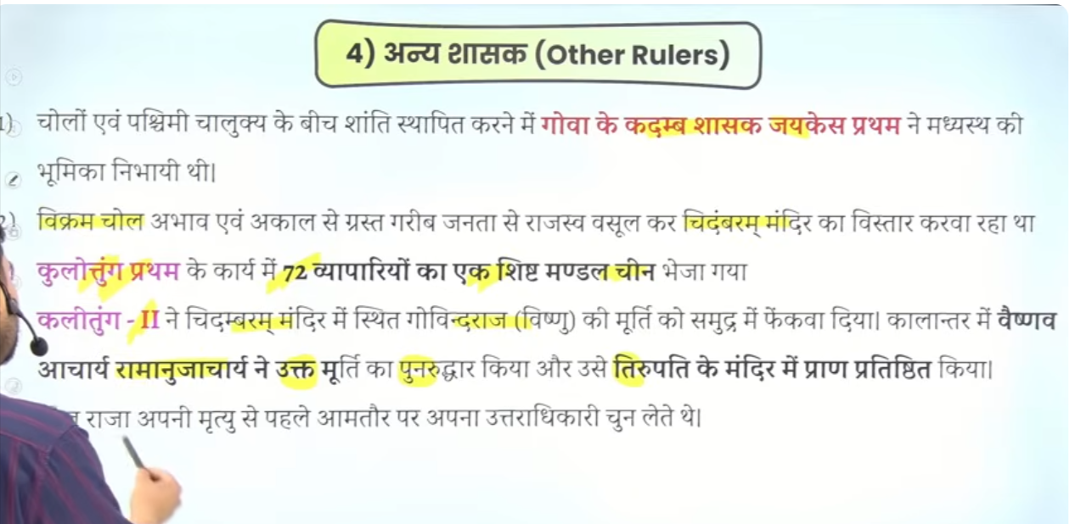
China se tradeko badane k lyei 72 vyaparyon ko beja tha
Ye unkie veshseta the ke wo apne mratu se pahle apna utradhekare chun lete the

Chola adminstation
Chola ka prashaan ishtaney parashan and nausena ke lyie famous tha
Primary wo local government ke lyie famous tha 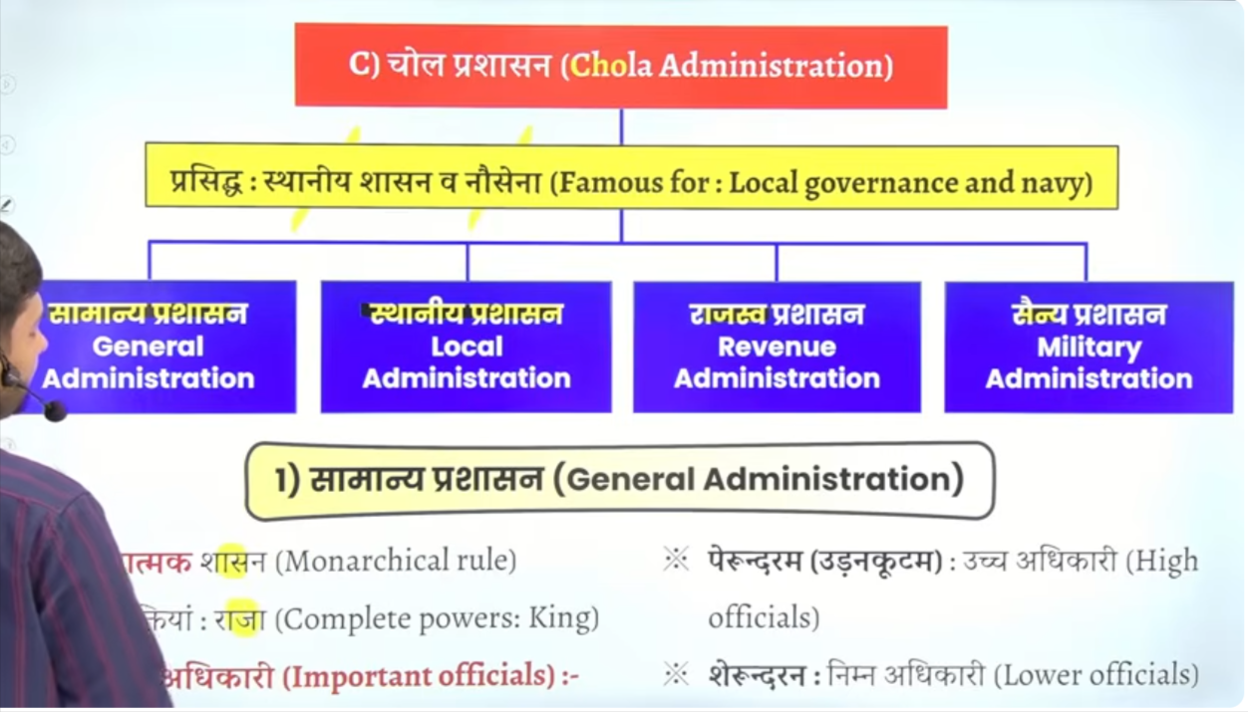

rrratntratamk shashan tha jaah sahre sthatkya rjaaj ke paas hote the
rjaj ko madad krne k lyei do tarah ke adhikare hote the high officials and lower officials

rajay nimn ikaee state are divided into 5 units
samrajaya,
samrajya ka vibhajan prant province jinhe mandal kaaha jata tha
mandal ka vighajan like district kottam kahah jata tha
vaalnadu ko nadu me bata jata tha
nadu ko Kurram and
Kurram ko gram me bata jata tha

Gram village is the smalal unit of chola adminstation
So empire is classified into mandal then madnal is clasidfided into kottam valnadu , so on…

Kurram is the group of villages
So village is the smallest unit of chola administration

Shalabhoga – school ko daan me de gae bhumi
Land dontate ofr educational institute
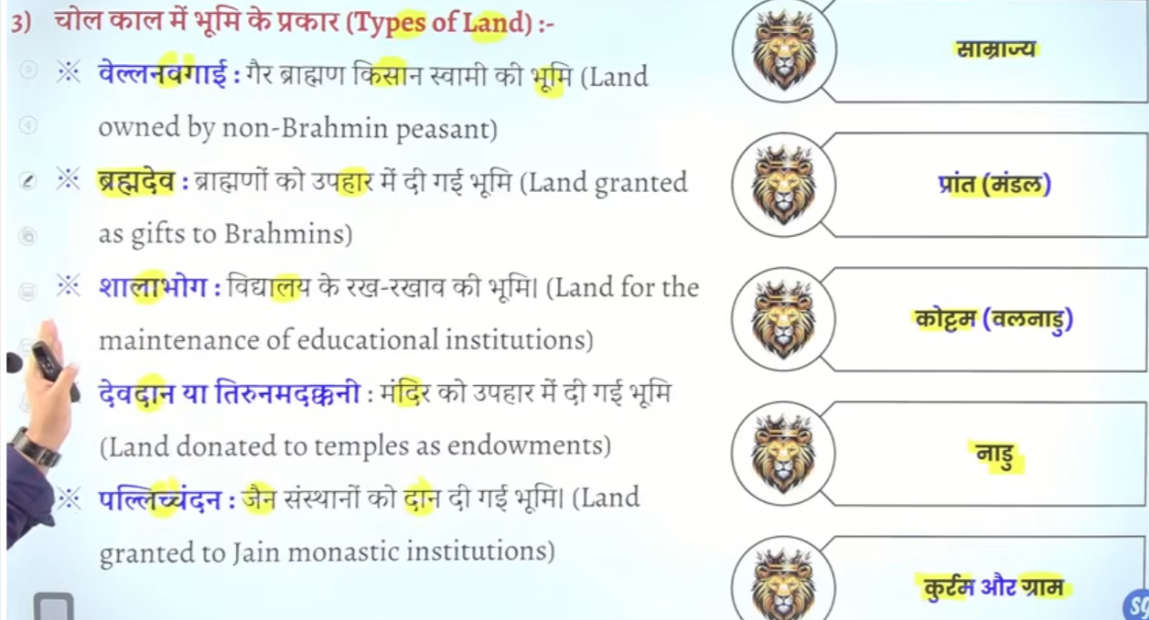

Local governance ishtaneya prashahsn
Ishaneya prahsahn ke lyie kaun prasedh the to answer is chola praseedh the

Chla prashan ke sabse important feature tha ki iske jankare hum prantak Pratham ke uttrameru inscirtoin se iske jankaire milte hai
Shashan ko chalne ke lyie teen prakar ke assemblies sabhaye the aur kae prakare ke sameetya tha
To sabha aur samiti milkar ke pura prashans chalte the

Gram sabha ke paas bahut sare power the like wo justice ka karya bhe karte thei wo rajasva sanrah ka karya bhe akrte the wo punshiment den ka bhe karya karte the to unke paas power bhaut the
So gram sabha has immence power of judiciary they had poer of executory theyw alow responsible for collection of taxes

There were three assembly and multiple committee to govern the village

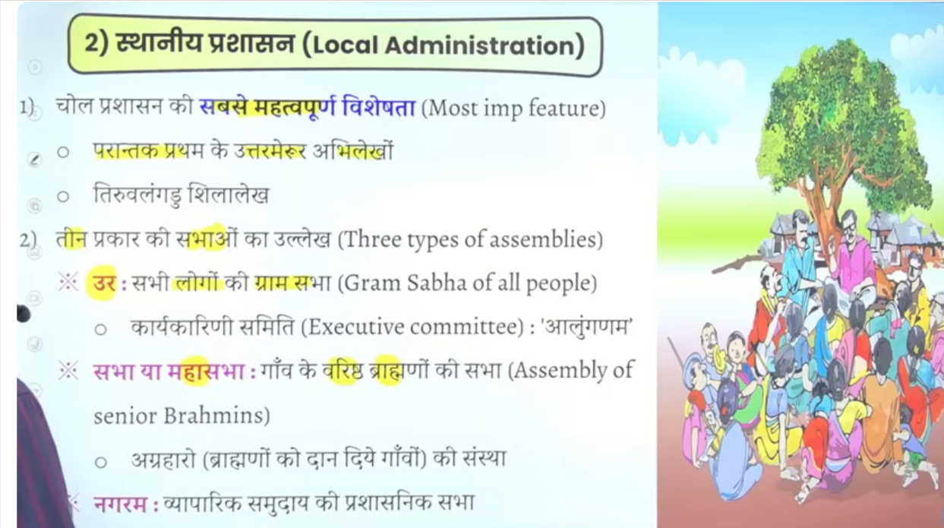

Nagram ke do reference dekhne ko milte hai
Shuru me nagram traders vyaparyoion ke ek sabha hote the fir nagram bhaut bada hota chala gya fir aise kuch gaon ban gae jaha sirf vyaparee rahte the
To iaise goan ya aise shaar jine vyapareoin ke dwara basyaa gaya unhe nagram kaha gaya tha

To sabse important tha ur ur alaga alag committee ke help se shasn karte the

Samitit committee ko vareyam kaha jata tha aur ek committee ka karyaakal 360 dino ka ya ek saal ka hota tha
Agar samitit ka sadasay apko baanan hai to kuch sarto ko pura karna hota tha

Ur = village sabha
Fir iske andar multiple committee bante hai
Like koi forest dekhegte koi janm maran ka lekah dekhege ko trade ko dekhege

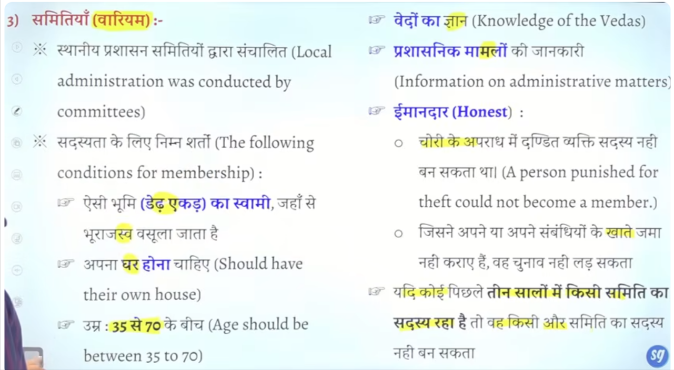

Aaj ke time per retirement age nahi hai rajyasabha me wo bhe bana dena chaoel like chola time
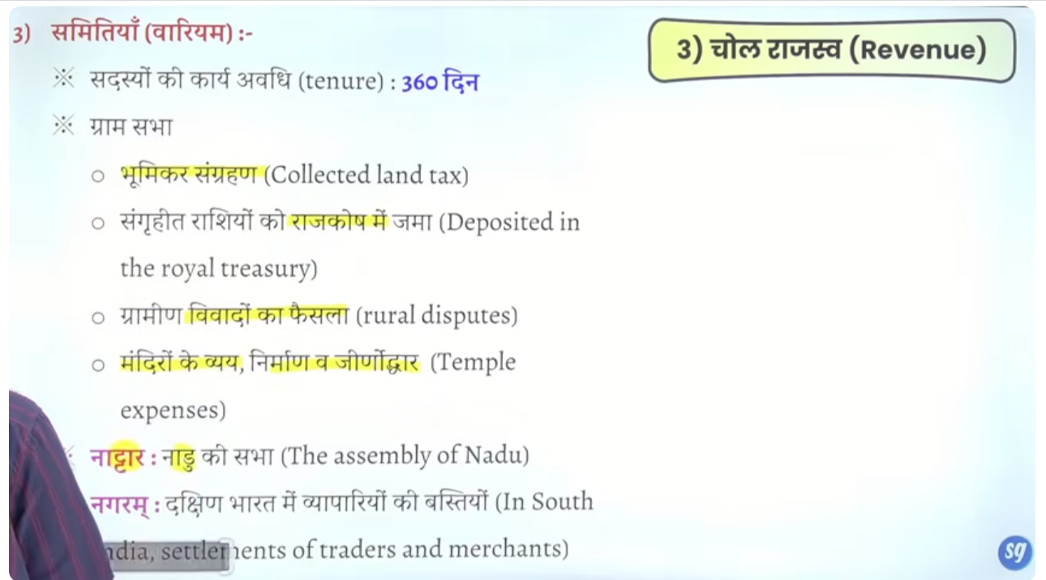

Gramin prashaahsn cholo ke mahtavapurna veshesta raheh hai it has been the most important feature of cholas

Gramin prashan ko har rajaj ne badawa dyia to har rjaja ne isko acha karne ka pryasa kyai tha
Gram sabhah jisko ur bolte the isme sabhe log samil the non brahmin
According to Vajiram & Ravi, the Ur in Chola administration was a general assembly/council of residents in ordinary, non-Brahmadeya villages (villages with peasant proprietors). It was a key local self-governance body responsible for land management, tax collection, and maintaining tanks and temples.

Iske alaaw aaur bhe samiteya the like
Nattar = nadu ke samitie hote the
Nagram – vyapareyon ke samiti ya traders dwara basaye gae shahar ko nagram kahte the
Sabha ya Mahasabha = iske gaon ke elder brahmin villager ke sabha hote the
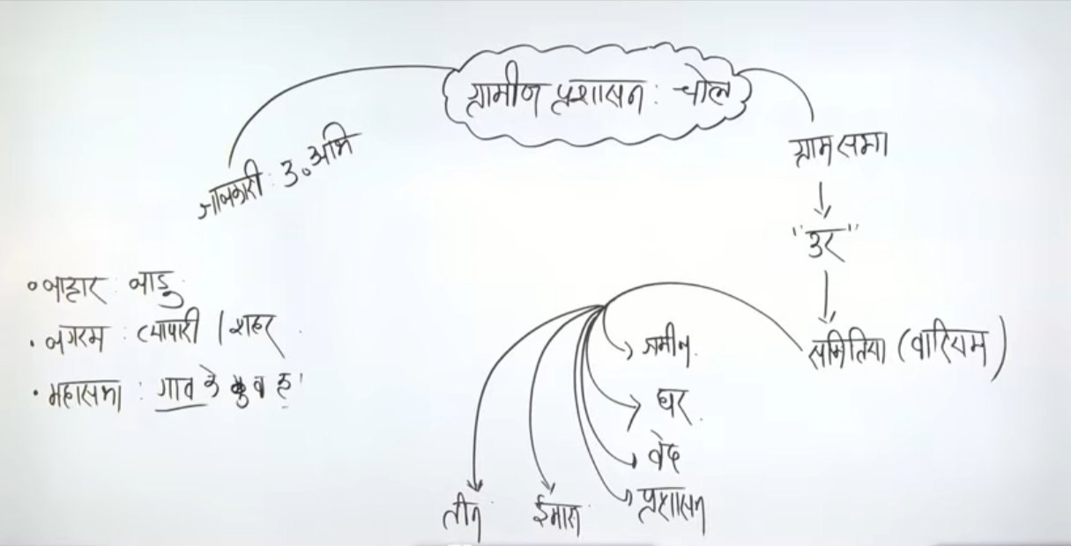

Rajasva me
Vegar ko veetee kahah jata tha
Bhumikaar sabse important hota tha aur generally income ka 1/3 jhota tha aur
Bhurajasv ke lyie kadmaie shabhd ka use kyia gaya hai

Sone ke sikke ko kasu kaha jata tha
rrajva ko ayam
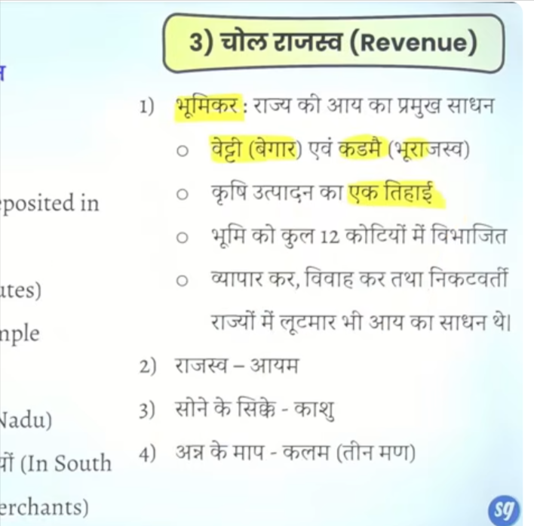

Society

Chola samaj me varn vyavasth nahi he ek the brahmin and ek the non brahmin
Baki sare cheze the like untouchablilty the , baal vivha tha sati ke praman bhe ahi ye sare buraee the but samaj mukhya roop se do bhago me divide tha braham and non brahmin

To hum kaha sakte hai ke samta mulak samaj Anahi tha egalitarian society nahi the

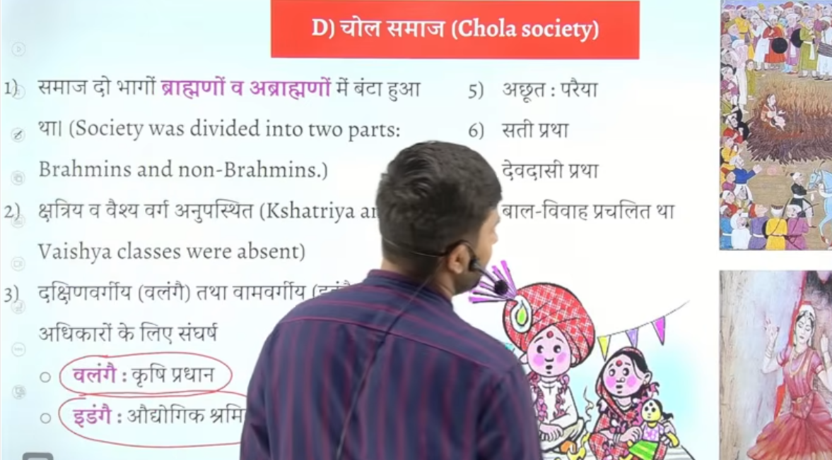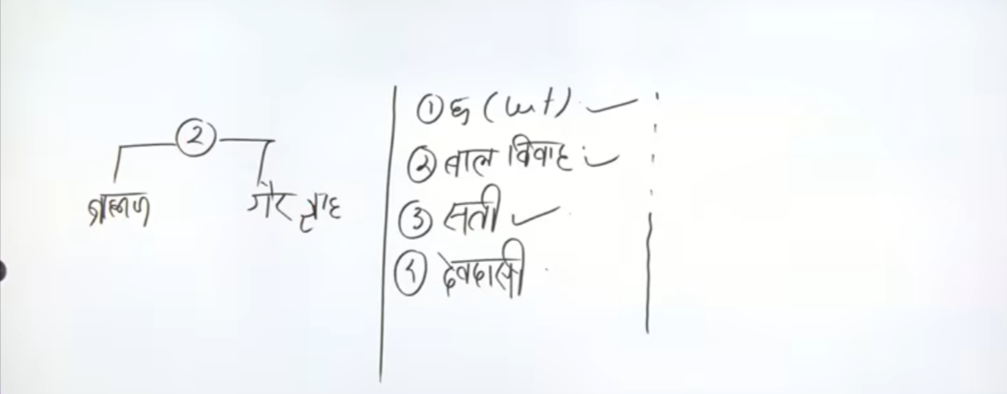

Art

Mandir and murityon ka bhaut vikasss hua hai chola ke time per
Dravin kala apne highest level per pauch jayege
rrssharma likhete hai ke chola ke mandir rajya ke andar rajay hai

nratya ruupom me bhagan shvvva ko tandavam ,nadanta, ardhanareshwar kakah jata tha
ye kansya bronze se bante the ye chola kaal ke sabse famous idol hai
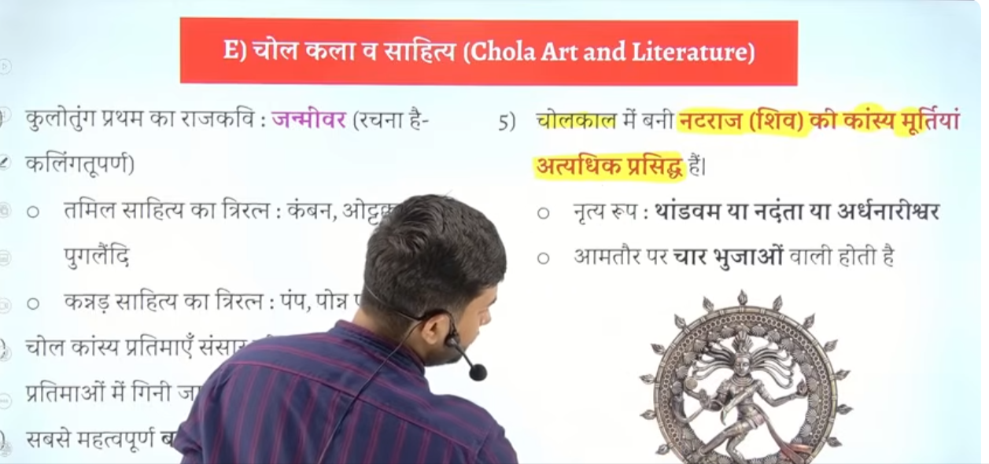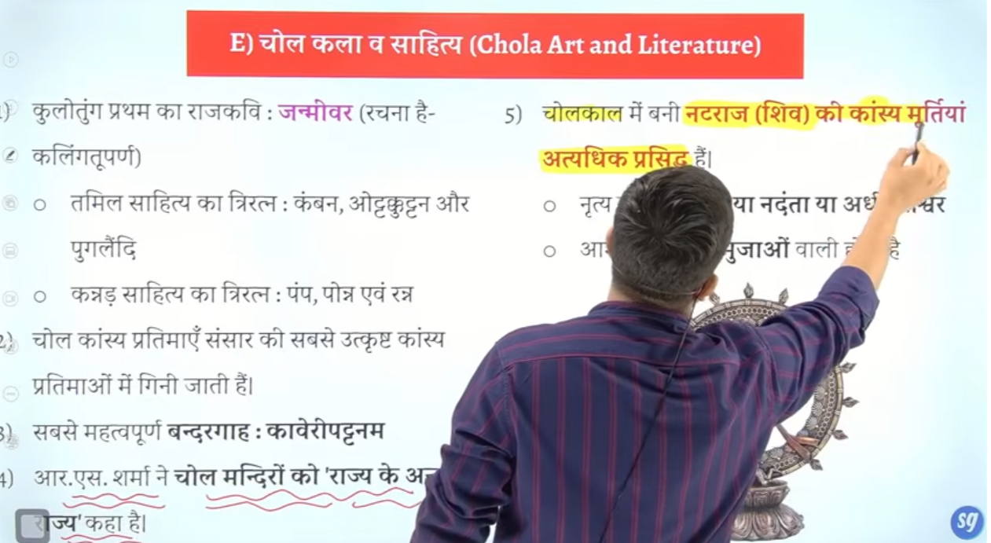

To chaar bhujaon wale kansaya mudra jo ke Natraj kahte hai ye chola kaal ke sabse praseedh akratyion me shamil hai

Shvvvva ke ek dakshinamurti bhe milte hai jisme Bhagwan ek teaher ke rroom me hai
To Bhagwan ke sjo shikshak ke roop me murti milte hai wo bhe hume south se chola time per mitle hai

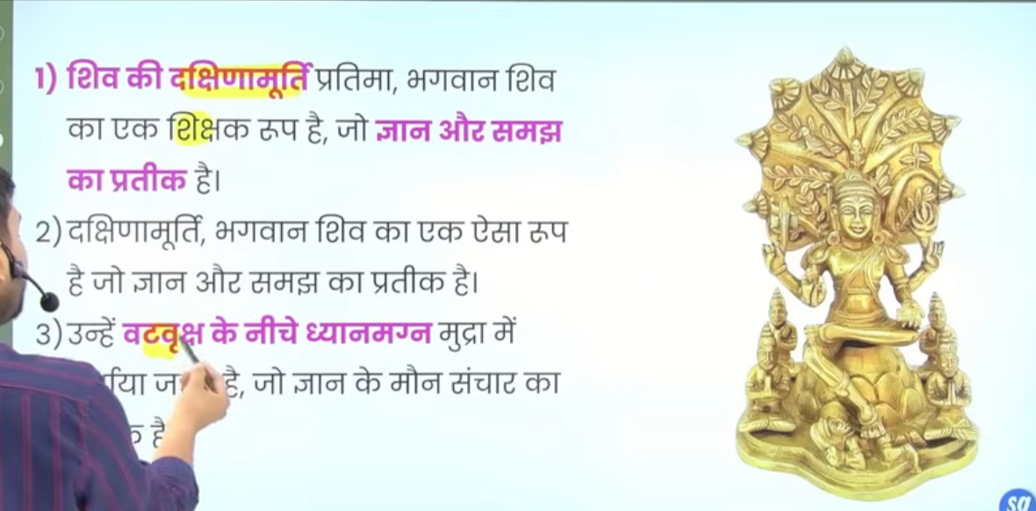

Haal he bharam me g20 sammelan ka ayojan kyai gaya tha ujseklye jo paresar banya gayay tha
Use bharat mandapam kaah gayay thaaur wo delhi me banany gyay tha to bhart mandampmke praveshw dwara per Natraj murti lagae gae the
Halake ye bhart ke sabe bade Natraj murti hai jise banay tha radahaha krsihnana isthapte hai isme 8 metal ka use kyia gaaya ahi

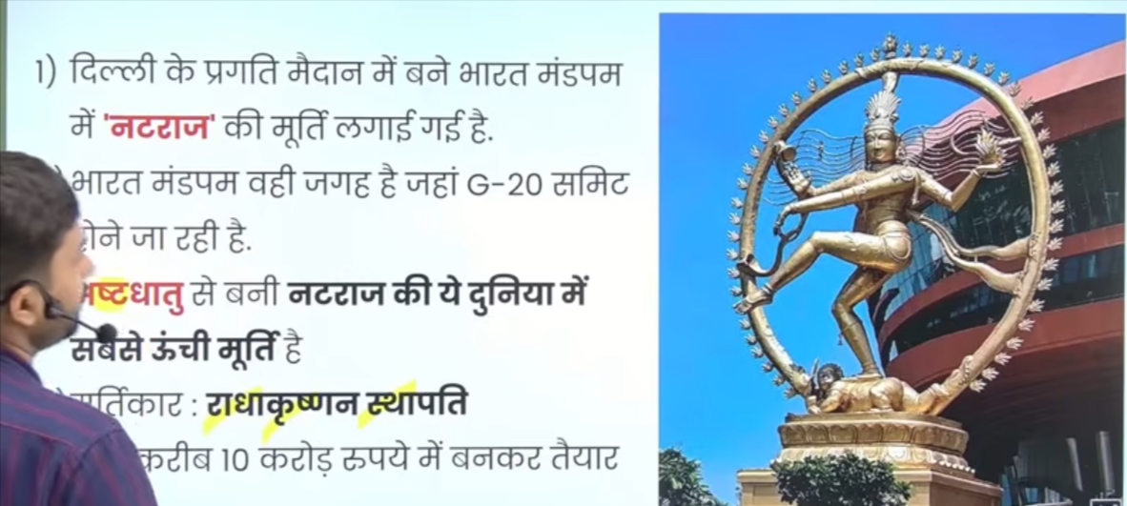
Aur ye cholo ke ithaas se jude hue hai
Isme bhe char hath ya char mudraye dekhne ko milte hai

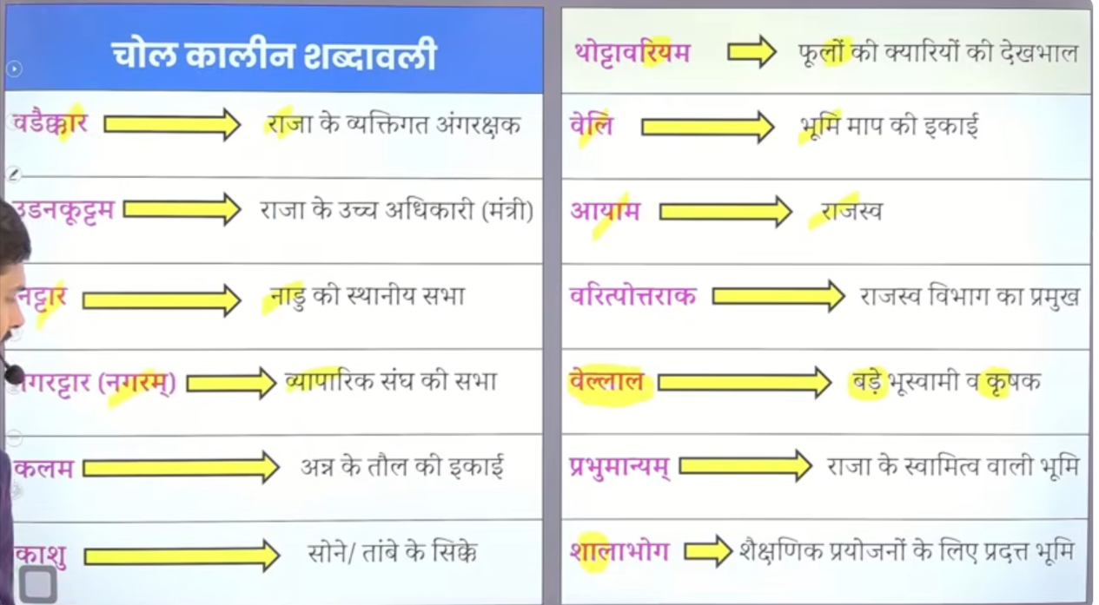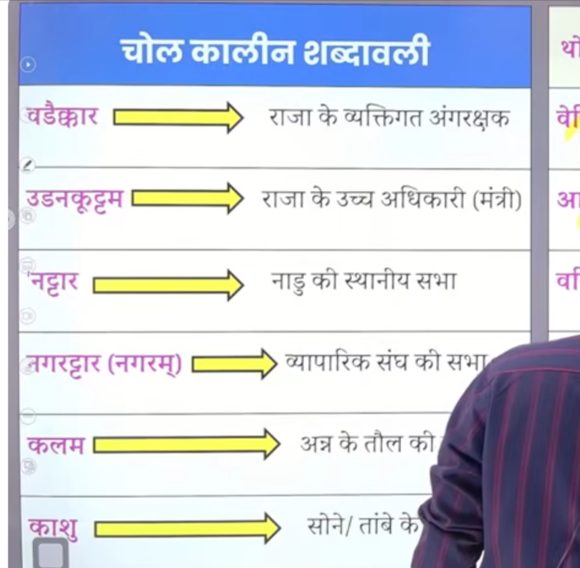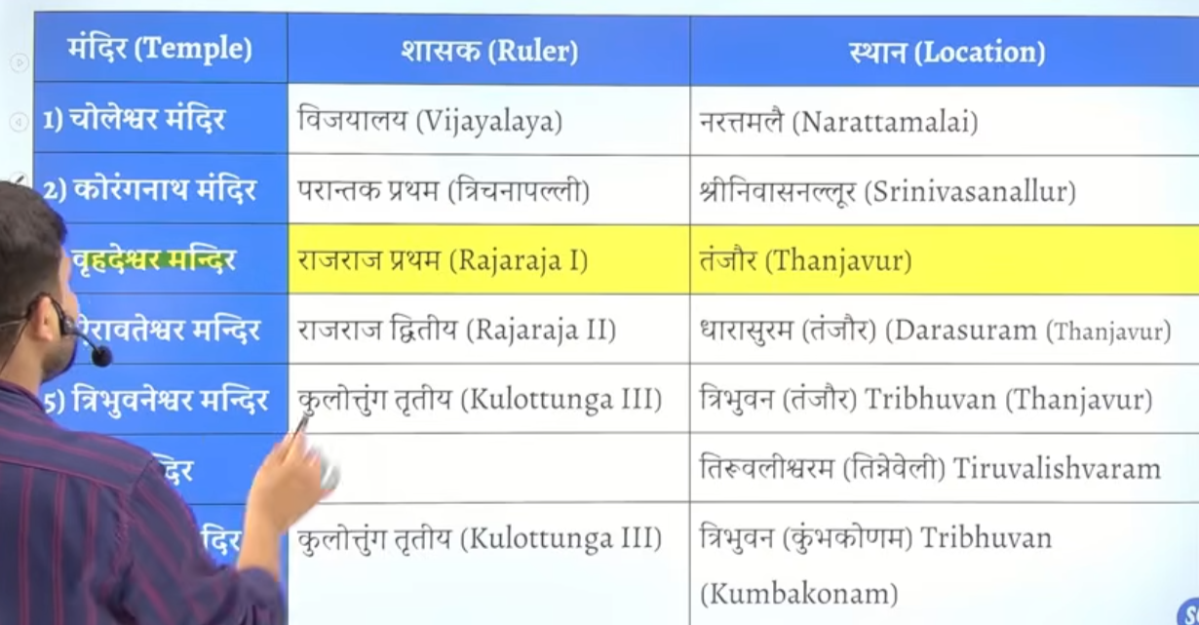

Tambee ke sikko ke lye kashuu sabh ka use hua hai

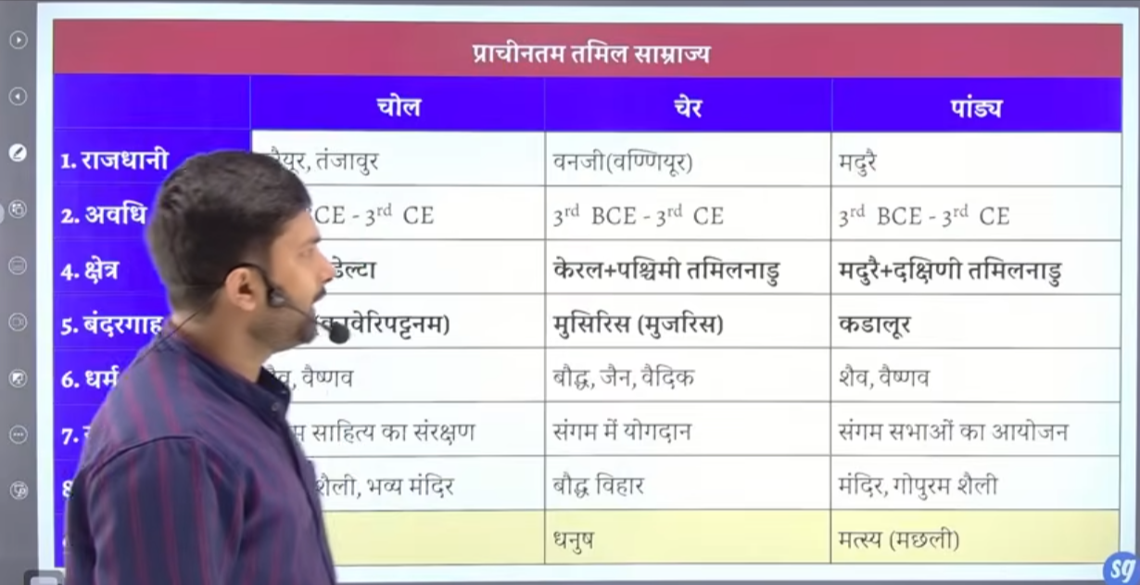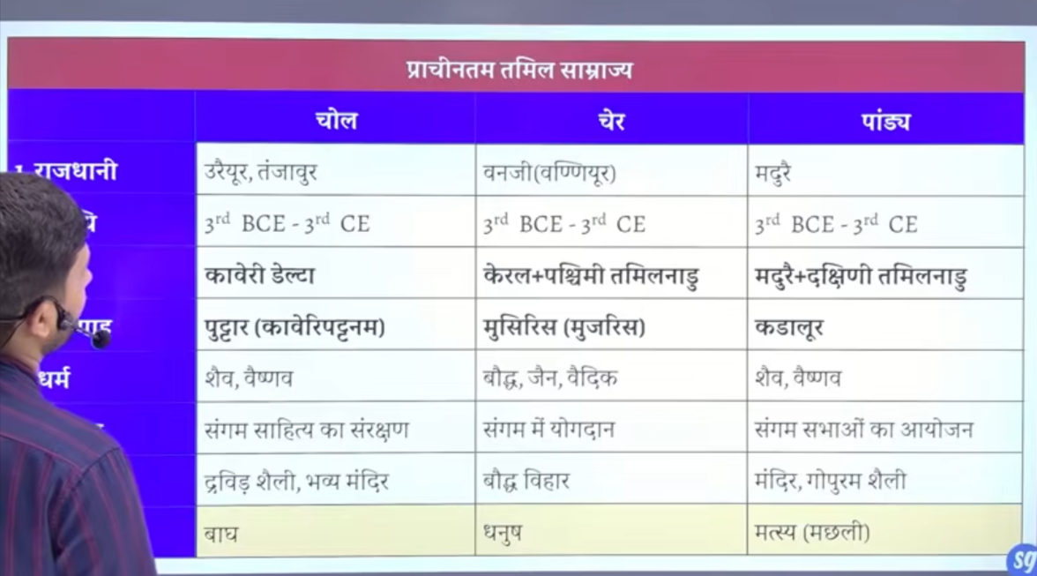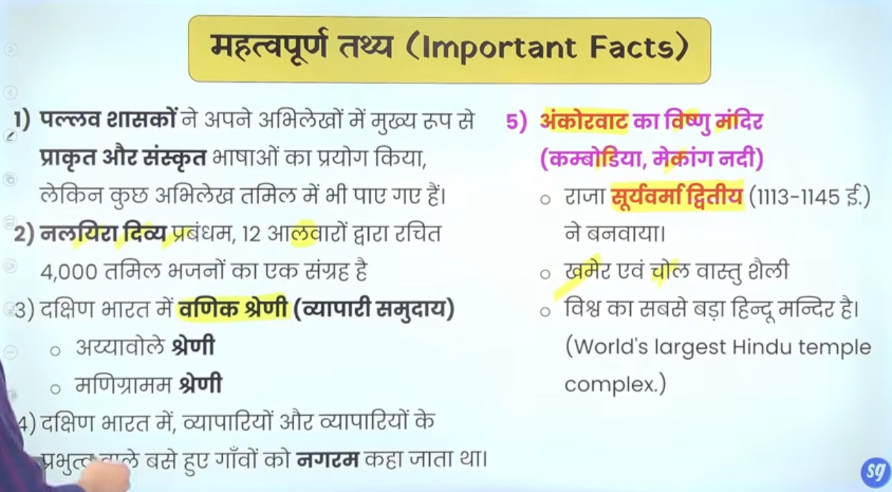

Jo sourth east asia ke island the yaha per cholo ka adhikar hua hindu sanskrti yaha per fiale to isse kram me combodia me ek mandir ankorvat ka mandir jo ke Vishnu bhagawna ka hai megang nadi ke kenary combodia me ahi
Wo ilaka jaah survarama second sahshan kar rahe the jisem combodai, campochia , aur Thailand ka ilaka ata tha use khameer kaaha jata tha
Aur is madir me kahameer and chola vastu kaala ka misran hai

To quesotn ankorvat mandir kaha ishta hai
To answer ankorvat madnir combodia me is the bhagwaan Vishnu ka mandir hai

Jiase sherni north me the waise he south me bhe this jisee mandigram bote the
Aur ek ayyavole sheri the

